Hall Technologies • 1234 Lakeshore Dr Suite #150 Coppell, TX 75019 • halltechav.com

HT-RANGER
BYOD Presentation Switcher
API Command List
Version: 1.0

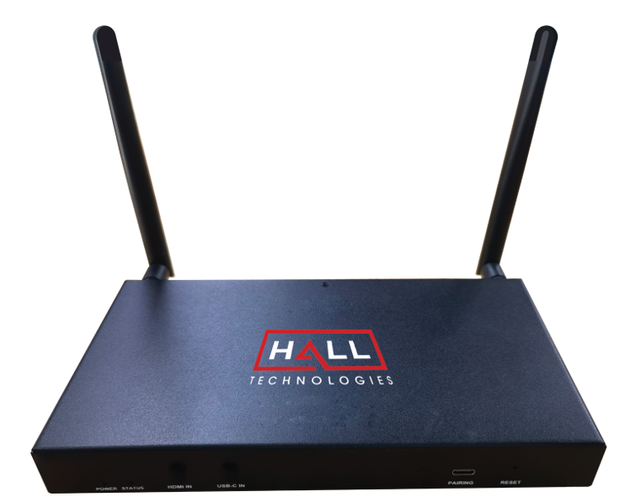

COMMAND LIST TABLE OF CONTENTS
Connecting to the HT-RANGER 3
IP Address 3
Enabling Telent Client 3
Logging in Via Command Prompt 4
Terminology & API Commands Overview 5
Terminology 5
API Commands Overview 5
API Commands 6
htconfig Commands 6
htcontrol Commands 8
htlayout Commands 8
Events 9

Connecting to the HT-RANGER

IP ADDRESS

To connect to and communicate with the HT-RANGER, the controlling device needs to be on the same network. If needed, change the IP address on your PC to be in the same IP range and same subnet as the HT-RANGER. You can find out the IP address of the HT-RANGER by looking in the bottom right corner of the Guide Screen (you will need to connect the HT-RANGER to a display).

ENABLING TELNET CLIENT

Before logging in to IP controller via command-line interface, make sure that Telnet Client is enabled. By default, Telnet Client is disabled in Windows OS. To turn on Telnet Client, do as follows.

- Choose Start > Control Panel > Programs
- In the Programs and Features area, click Turn Windows features on or off.
- In the Windows Features window, select Telnet Client check box.

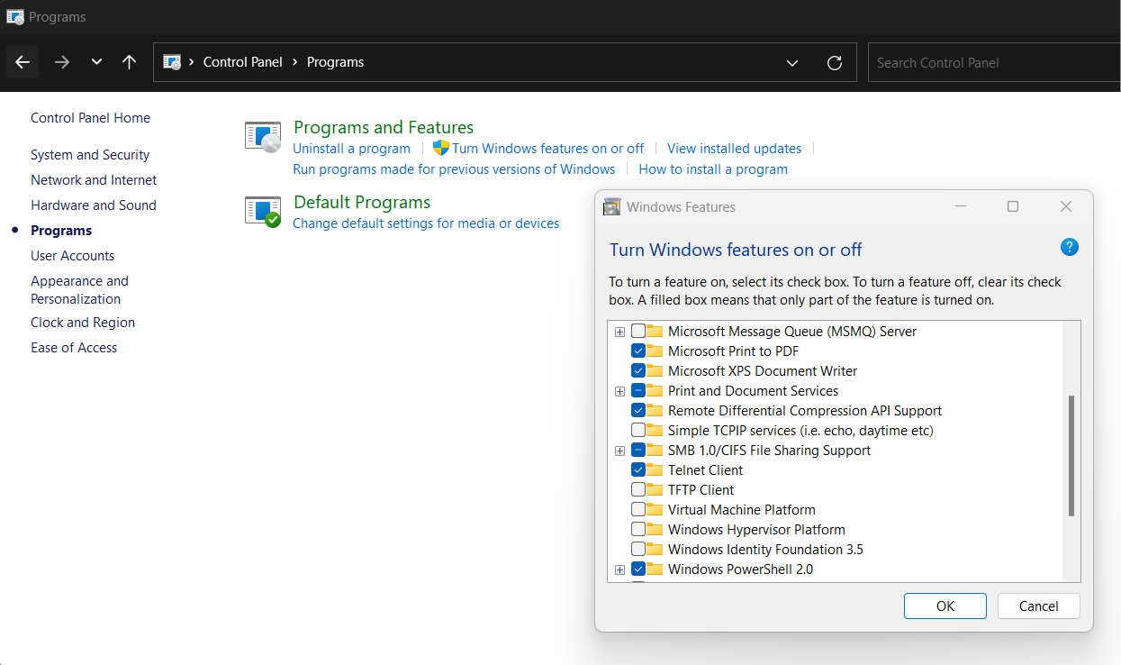

LOGGING IN VIA COMMAND-LINE INTERFACE

- Choose Start > Run
- In the Run dialog box, enter cmd and then click OK.
- Enter telnet 192.168.0.109 23 if the device’s IP address is 192.168.0.109 and then press Enter. (The 23 on the end changes the port communication to 23).

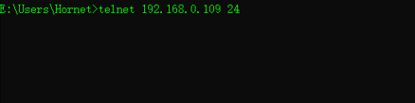

- The device will display a # as the command prompt. The device is now ready to execute the API commands.

Terminology & API Commands Overview

TERMINOLOGY

The terminology used in the API command’s description is listed as follows:

- Device: the unit being controlled
- AirPlay Mirroring: A screen mirroring approach developed by Apple and is supported by many Apple devices such as MacBooks, iPads, and iPhones.
- Miracast: A screen mirroring approach developed by Wi-Fi alliance and is supported by all Android devices and Windows PCs.
- BYOD Source: AirPlay and Miracast are BYOD solutions.
- Hardware Source: The physical hardware interface on the device, such as HDMI or USB Type-C.
- Software Source: Certain devices can display video content from a USB camera.

API COMMANDS OVERVIEW

API commands are mainly classified into the following types.

- htconfig: manages the configurations of the device
- htcontrol: controls the device
- htlayout: adjusts the features related to the screen layout
- Event: message from the device to report that the device’s state changed

Command syntax uses the command type followed by a space, two dashes, and then the command plus the argument (as needed). For example:

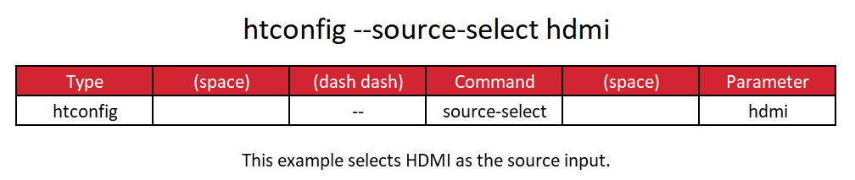

Note: For the “show” command there is only a single dash: htconfig -s source-select

API Commands

HTCONFIG COMMANDS

Command | Parameter(s) | Description
htconfig --help |  | Displays a list of all available htconfig commands.
htconfig --name | {DeviceName} | Configure the device’s name. The new name will appear on the top-right corner of the screen. The default device name is HT-RANGER.  Note: The device name must be 1~20 characters in length and can include only letters, numbers and two special characters (‘_’ and ‘-‘).
htconfig --output-resolution | {auto | timing} | Changes the output resolution. Default is set to auto.  Timing: 1920x1080P@60 | 1920x1080P@50 | 1920x1080P@30 | 1920x1080P@25 | 1920x1080P@24 | 1680x1050P@60 | 1600x1200P@60 | 1440x900P@60 | 1366x768P@60 | 1280x1024P@60 | 1280x720P@60 | 1280x720P@50 | 1024x768P@60 | 800x600P@60 | 720x480P@60 | 640x480P@60
htconfig --auto-switch-source | {y | n | toggle} [runtimeonly] | Configure the automatic switching feature. If it is enabled, when a video source is connected the output will automatically route the connected video source.  The second parameter is optional and changes the switching temporarily (reverts back with device reboot or standby mode).
htconfig --lan-info | {dhcp | static ipaddr netmask gateway [DNS] } | Sets the mode of the LAN connection.
htconfig --hdcp-enable | {y | n} | Enables (y) or disables (n) the HDCP feature on the HDMI output. If enabled, HDCP 1.4 will be used on the output. Default is enabled.
htconfig --auto-standby-time {TimeOut} | {0 ~ 60} | Configures the timeout of the automatic standby (sleep) feature, in minutes. A setting of 0 disables the automatic standby feature. Default is 1 minute.
htconfig --sinkpower-mode | {cec | none} | The device can turn on/off the external display using CEC. Default is set to CEC.
htconfig --special-sink {TimeOut} | {0 ~ 200} | Sets the interval between two CEC commands from the device to the display, in seconds. Default is 8 seconds.
htconfig --source-select {VideoName} {WinNo} | {HDMI | USB-C | GUIDE | NULL | airplay1 | airplay 2 | miracast1 | miracast2} | Select the source to be displayed (first parameter) and set the window for it to be displayed in {second parameter}. The window number is optional, and if omitted the source will be displayed in full screen mode.
htconfig --media-source alias {VideoName} [Alias] | {HDMI | USB-C | GUIDE | NULL | airplay1 | airplay 2 | miracast1 | miracast2} | Changes the alias name of the video source. The alias cannot be any predefined video name such as HDMI, cannot be a decimal number or a hexadecimal number starting with “0x” or “0X” and cannot start with a “-“ or include any spaces.
htconfig --media-source list | - | Displays the video name and the alias. If no alias is given the video will not be shown on the list.
htconfig --input-state [VideoName] | - | Displays the detailed state of the video source.
htconfig --audio-select [VideoName] | {HDMI | USB-C | GUIDE | NULL | airplay1 | airplay 2 | miracast1 | miracast2} | Selects the audio source to route to the HDMI output. Default is the last video source connected.
htconfig --access-code | {AccessCode | Auto} | Sets the access code for a BYOD device wirelessly connected. AccessCode must be 4 digits. If Auto is selected the device will automatically create an access code. If nothing is entered as the access code (NULL) the access code requirement is disabled.
htconfig --softap-password | {Password} | Sets the password for the Soft AP. Default is 12345678.  Note: the password must be 8~20 characters in length and contain only letters, numbers, and two special characters (‘-‘ and ‘_’).
htconfig --softap-enable | {y | n} | Enables (y) or disables (n) the Soft AP.
htconfig --byod-enable | {y | n} [runtimeonly] | Enables (y) or disables (n) BYOD. Adding “runtimeonly” reverts back when rebooted or when the device goes into sleep mode.
htconfig --preemption-mode | {y | n} | Enables (y) or disables (n) preemption mode. When enabled the next video source to connect will automatically be displayed. Default is enabled.
htconfig --wifi-mode | {2 | 5} {Channel | Auto} | Sets the band and channel of the WiFi module.  2=2.4G: 1~11, auto  5=5G
htconfig --softap-router | {y | n} | Enables (y) or disables (n) the soft AP Router.
htconfig --edid
htconfig --usb-host | {USBOutputPort | auto1 | auto2} | - Fixed: the USB output is connected to a certain target continuously. USBOutputPort has two optional values: 1 and 3, which matches the main SoC chip and USB-C port.  - Automatic 1: the USB output is connected to the USB-C port when the USB-C video source is valid, no matter if the USB-C video source is shown or not.  - Automatic 2: the USB output is connected to the USB-C port when the device shows video source of the USB-C port with full screen mode.
htconfig --fallback-priority | {VideoName | Normal} | Changes the video source the device falls back to when a video source is disconnected.
htconfig --show | - | Displays the settings of the specified item.

HTCONTROL COMMANDS

Command | Argument(s) | Description
htcontrol --help |  | Displays a list of all available htcontrol commands.
htconfig --reboot |  | Reboots the device.
htcontrol --reset-to-default |  | Restores the device to the factory defaults.
htcontrol --video-source | {VideoName} {WinNo} | Displays the selected video source to the desired window.
htcontrol --audio-source | {VideoName} | Selects the desired audio source.
htcontrol --stop-video | {VideoName} | Stops displaying the desired video source.
htcontrol --sinkpower | {on | off} | The device switches to or escapes from standby (sleep) state and sends the CEC command to the connected display.
htcontrol --show-osd |  | Displays the OSD for ten seconds.
htcontrol --set-layout-video [LayoutNo] | {VideoName1 [VideoName2]} | Sets the designated screen layout and the designated video source.
htcontrol --device-info |  | Displays information about the device.
htcontrol --switch-usb [USBOutputPort] | - | Routes all USB signals to the designated USB Host port.

HTLAYOUT COMMANDS

Command | Argument(s) | Description
htlayout --help |  | Displays a list of all available gblayout commands.
htlayout --start-video | {VideoName} | Starts the designated video and returns a list of the video sources being displayed.  - If the video source is displayed already, the device does nothing.  - If there is no free window, the device switches to a screen layout which has more windows  - If there is no free window nor screen layout having more windows, the device stops playing the “oldest” video source.  Note: If the device is disabled to change the screen layout automatically, this command will not work. Refer to the gblayout --auto command.
htlayout --stop-video | {VideoName} {WinNo} | Stops the designated video.
htlayout –-show | {LayoutNo} | Displays the detail of a screen layout.
htlayout --set | {LayoutNo} | Sets the current screen layout to the desired number.
htlayout --get | detail | Displays information related to the current screen layout. Adding detail to the command provides the position and size of every window and the video source displayed in the window.
htlayout --set-sequence | {Layout1No} {Layout2No} | Designates the screen layout sequence (either full or dual view)
htlayout --get-sequence |  | Displays the numbers of all layouts in the sequence.
htlayout --list |  | Displays all screen layouts in the device.

EVENTS

Events are not API commands that can be sent by the controller. These are messages sent by the device to announce that a certain state of the device has change.

Command | Description
[Event] VideoSource VideoName | This message means that the state of one video source has changed.
[Event] WorkMode | This message means that the device’s work mode has changed.
[Event] Layout | This message means that the screen layout has changed and includes the layout ID and its name.

© Copyright 2022. Hall Technologies
All rights reserved.

1234 Lakeshore Drive, Coppell, TX 75019
halltechav.com / support@halltechav.com
(714)641-6607

